Year 8 Earth and Beyond Quiz 2

Name: ____________________________ Mark: _______/20
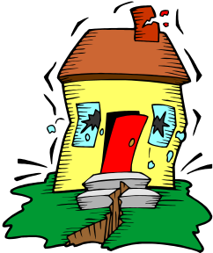

The diagram shows a house being shaken in an earthquake

- What is an earthquake?
(2 marks)
Earthquakes are any rapid movement that occurs in the Earth’s surface and are felt as a tremor or shock.

- What is the cause of an earthquake?
(2 marks)
Movement of the crustal plates or repositioning of rock from changes in the crust.

- The map below shows the major crustal plates.

  - Use arrows and the letter E to identify on the map two places where an earthquake is most likely to occur.
(2 marks)
  - Use arrows and the letter V to identify two places where active volcanoes are most likely to exist.
(2 marks)
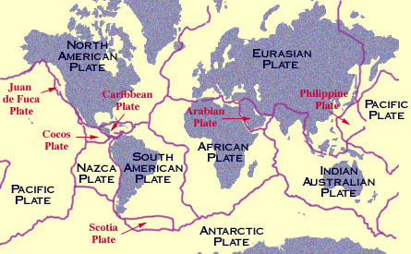

V

E

V
E

- Complete the following sentences using a word from the box below.
(8 marks)
erosion, weathering, fossils, epicentre, plates, cast, glacier, magma, seismometer, magma, mould, tsunami, same, different, volcano, fault, fold

seismometer
  - A _____________________ is the instrument used to record earthquake activity.
epicentre
  - The ________________ is the point on the earth’s surface above the focus of an earthquake.
tsunami
  - Earthquakes near coastal areas could cause a ____________________.
erosion
  - ________________ is the transport of rocky material from one place to another.
weathering
  - The wearing away of rock is called ______________________.
plates
  - The earth’s crust is split into large sections called ________________.
magma
  - When _______________________ moves up the neck of a volcano it is called lava.
fault
  - The Darling Range was caused by a ________________ in the rocks.

- Mountains have formed by faulting and folding. Distinguish between these two processes.
(2 marks)
A fault is where tension forces are trying to pull the crust apart or compression forces are pushing the crust together at weak areas of the crust, whereas a fold is the bending of rock due to pressure exerted on it.

- Explain the difference between weathering and erosion?
(2 marks)
Weathering is the process by which rocks are broken down into smaller pieces where as erosion is the process of transporting weathered rock from one place to another.

